DEAR COLLEAGUES!

We invite you to take part in the work of International theoretical and practical conference «Researches, nanosystems and
alternative technologies in building materials industry» (XIХ academic readings), which will take place
on 5-8th October, 2010 in Belgorod Shukhov State Technological University .

Reference directions

- Nanosystems in building material science

- Alternative technologies in binding and composite materials production

- Effective materials, technologies and building machines

At conference, VII International theoretical and practical conference of young scientists, post-graduates and doctoral candidates, devoted to V.G.Shukhov`s memory
will take place.

Documents submission
For participation in the conference it is necessary to send to the Organization committee
before 1st July,2010:
- Application on participation
2Printed original of the report, which is formed according to given requirements and signed by the authors.
3Report (not more than 30 words) in Russian language and full name of the author.
4Electronic version of the report.
5Copy of payment order.

Norms of papers execution

For participation in the conference it is necessary to form and send on e-mail conf@intbel.ru (files may be packed by archivers RAR, ZIP):
1Application on participation .
2A copy of payment order (scanned figures of receipts).
3Теxt of the report.
4Report – not more than 30 words.
The materials of the conference should be done in the form of book page, format- А5. The pages should be completely filled.
The text is typed in WinWord. Type- "Times New Roman", type size-10. Line space- 1.
The figures should be done in vector format (autotype image with definition not less than 300 dpi is admitted) in one of graphics editors: Сorel DRAW, AUTOCAD; or in attachment MsOffice. Figures, photos and tables should be embeded in the text, for the author in suitable form.
Formulas should be embedded in the text of the report and must be done with the help of editing program Equation Editor or Math Type, which is embeded in WinWord.
Reference is formed according to requirements of State Standard 7.1-2003.
The title of the report is typed by capital letters. Surname and initials of the author, degree, rank are under the title. On the next line, indicate the full name of your organization in italics (small letters) and then, the main text follows.
Margins: upper − 17 mm, lower − 30 mm,
left − 18 mm, right − 20 mm.
Indent of the paragraph - 7 mm.

How to form the text of the report
crack formation of Аsphalt concrete pavement
Ivanov I.I., PhD (technical science), assistant professor.
Belgorod Shukhov State Technological University

Основной текст.

Attention!
Reports should be carefully edited.The author is responsible for the content of the report.
The reports which don`t meet the requirements listed or arrive after the specific date aren`t published.
Accomodation is in the hotel “AMAKS KONGRESS-HOTEL.” You may find the price-list for reservation on your numbered fund.
To confirm your participation in the conference, please inform the Organization committee about the date and time of your arrival, the number of your flight, the number of your train, te number of your carriage before 10 th September,2010.
We recommend you to buy return tickets in advance.

ARRANGEMENT FEE

Arrangement fee, which includes the costs on works and information messages publishing, postages is 600 rub.
for five full pages, and additional payment 100 rub. per each extra page .
Arrangement fee is transferred
before 1st July, 2010: AFC on Belgorod region(Belgorod Shukhov State Technological University b/b 03261А29220), ID 3123017793, RCGR 312301001 b/a 40503810000001000003 in SCCC of Russia Bank on Belgorod region,
Belgorod BIC 041403001 with remark in payment order: income code 07430201010010000130 for participation in the conference «ХIХ academic readings» and participant`s full name.

Young scientists (before 28 years old included ) can be selected as participants of the programme
«UMNIK»
(http://www.fasie.ru/index.php?rid=120)
Winning projects will be financed of 200.000 rub. pur year.

Аddress of Organizing committee :

308012, Kostyukov street, 46
Belgorod, Russia,
Belgorod Shukhov State Technological University
DSТI and DSRW
Contact tel../fax: (4722) 55-17-49

е-mail: conf@intbel.ru
http://conf.bstu.ru

Оrganizing committee

application
for participation in International
theoretical and practical conference
«Researches, nanosystems and alternative technologies in building materials industry»
5-8 October, 2010

Surname
Name
Second name
Post
Degree
Academic rank
Organization (full name)

Аddress

Теl.,fax, e-mail

The title of report

The title of report

Participation in programme «Umnik» (yes/no)

Necessity of technique

Form of participation(full-time/extra-mural)
Seat reservation in hotel (category of the room is according to price-list)

Date of arrival
Signature of participant

Federal agency on education

Russian academy of architecture and building sciences

Administration of Belgorod region

Belgorod Shukhov State Technological University

Non-profit partnership «Interregional association of scientists and specialists in the sphere of building material science»

Specialists association on innovative activity «Technological park of Belgorod Shukhov State Technological University»

International
Theoretical and practical conference

RESEARCHES,
NANOSYSTEMS and
ALTERNATIVE TECHNOLOGIES
IN BUILDING MATERIALS INDUSTRY
(XIХ academic readings)

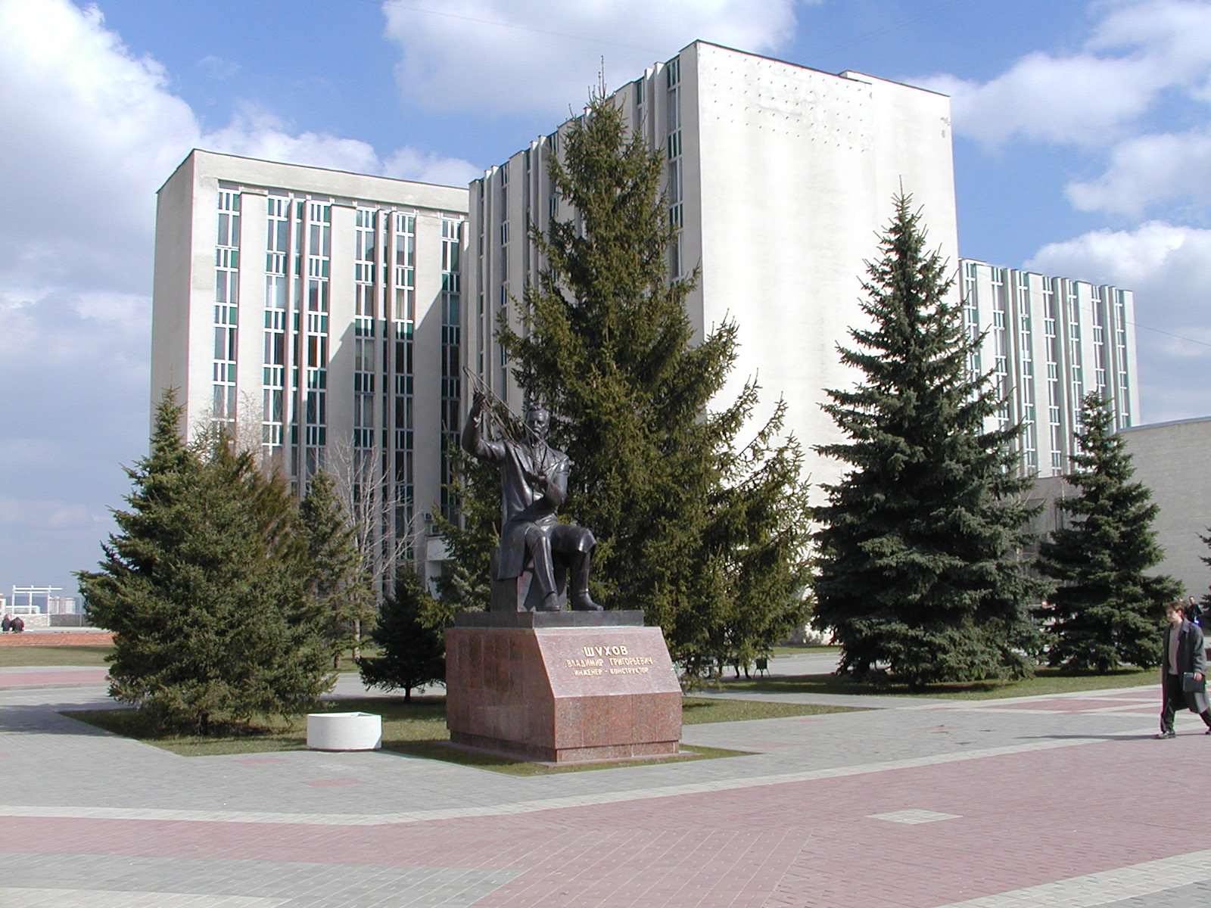

Belgorod 2010
5 -8 October

